
press release
(English translation)

ECOMONDO 2024: ARTIFICIAL INTELLIGENCE,
A KEY ROLE IN THE ECOLOGICAL TRANSITION
From 5th to 8th November in Rimini, the twenty-seventh edition of Ecomondo: applying artificial intelligence to the circular economy among the main themes of the 2024 edition, from environmental monitoring to the sustainable management of water resources
Rimini, 20 September 2024 - Ecomondo, Europe’s reference event for the green and circular economy, will be back at Rimini Expo Centre from 5th to 8th November 2024. Organised by Italian Exhibition Group (IEG), the event, now at its 27th edition, is a strategic international hub for exploring the technological solutions and policies needed to achieve a vision of sustainable development on a global scale.
The event is an essential opportunity to understand the current Italian, European and international levels of adoption of the circular economy in the main industrial supply chains in line with the NRRP and European Green Deal projects.
The show offers a full and authoritative programme of conferences, workshops, meetings and seminars. Events are organised by the Technical-Scientific Committee, composed of a pool of over 80 experts chaired by Professor Fabio Fava, in cooperation with national and international institutions, trade associations, consortia, agencies and sector federations. Participants will have the chance to keep up to date with the sector’s latest trends, technologies and regulations as well as to exchange views with experts and professionals of international calibre.
Artificial Intelligence, a key theme at the 2024 edition, will be explored in depth in all the show’s main macro-areas, demonstrating its crucial role in accelerating the transition towards a circular and sustainable economy. According to a recent study conducted by EY Italy AI Barometer, Italy ranks third in Europe for the rate of AI adoption in businesses with 85% of companies using at least one artificial intelligence technology. Ecomondo 2024 is an ideal platform at which to explore this potential within the context of environmental sustainability.
In the Environmental Monitoring and Earth Observation sector, visitors will discover the most advanced AI solutions for acquiring and analysing satellite data in order to monitor the environment, biodiversity and agro-forestry production. Advanced satellite monitoring technologies, integrated with Big Data and artificial intelligence models, are key tools for tackling climate change.
The event “Indoor air: its role in the environment and health relationship”, organised by Ecomondo’s Technical-Scientific Committee and the National Institute of Health, will fit into this context. Moreover, the “Earth Observation Technologies to improve environmental management” session will explore the use of AI in Earth observation.
On 6th November, this area will also host the “Earth Observation - Scenarios for the Near Future” event, which will aim to explore the evolution and growing importance of Earth observation in various sectors with a focus on applications in Italy for monitoring hydrogeological instability, archaeological heritage, water dispersion and the development of intelligent agriculture.
The area dedicated to the Blue Economy will highlight the role of AI in optimising port management, preventing marine pollution, and the efficient use of water. An event of particular note will be “Digitisation and optimisation of water network efficiency”, organised by Ecomondo's Technical-Scientific Committee, the Marche Polytechnic University, Bologna University and UTILITALIA. This event will explore the application of AI in the analysis of big data and the creation of digital twins for the innovative and sustainable management of the integrated water cycle.
In the Circular and Healthy City district, the workshop entitled “Earth Observation and Digital Twins to improve Urban Resilience”, scheduled for 5th November and organised by Ecomondo’s Technical-Scientific Committee and Turin Polytechnic, will explore how AI can revolutionise urban management. The session on “Monitoring Urban Landscapes: The Power of Data and Digital Twins” will delve into the use of AI for urban monitoring, presenting case studies of cities using AI-based digital twins to simulate the impact of new infrastructure, optimise energy consumption and improve resilience to extreme weather events.
In the Waste as Resource area, AI will be presented as a key tool for optimising waste management. Visitors will be able to see practical demonstrations of machine learning for automated waste sorting and optimal collection route planning.
The Bioeconomy area will host sessions to discover how AI algorithms can reduce the environmental impact of the primary sector, improving resource efficiency and resilience to climate change. The session on “Drivers for a stronger and more competitive agrifood supply chain: between tradition and innovation, circularity, energy transition”, scheduled for 6th November and organised in collaboration with Confagricoltura, Federalimentare and ENEA, will take stock of the most innovative solutions for data-driven and sustainable agriculture and how algorithms can reduce the sector’s environmental impact by improving resource efficiency and resilience to climate change.
AI is showing significant potential in supporting economic, social and environmental sustainability. As highlighted by recent studies, AI can contribute to resource optimisation, waste reduction and the implementation of circular economy models. Ecomondo 2024 aims to explore these opportunities by offering a unique platform for dialogue between innovators, policy makers and industry.
With a format that combines a high-level exhibition area with a full programme of events, Ecomondo 2024 confirms its role as the reference platform in Europe for exploring the latest trends in digitalisation and sustainability. The event will provide visitors with a unique opportunity for a first-hand experience in how artificial intelligence can accelerate the green transition in all sectors of the circular economy.
The appointment is from 5th to 8th November 2024 at Rimini Expo Centre for four days of networking, training and business under the banner of sustainable innovation.
______________________________________
INSTITUTIONAL PARTNERS
Ecomondo 2024 is organised by Italian Exhibition Group in collaboration with: European Commission; Ministry for the Environment and Energy Security; Ministry of Enterprise and Made in Italy; ITA - Italian Trade & Investment Agency; Emilia-Romagna Region; Rimini Municipal Council; ANCI (National Association of Italian Municipalities); ANFIA (National Association of Automotive Industries); ART-ER; CIB (Italian Biogas Consortium); CIC (Italian Composters Consortium); CONAI (National Packaging Consortium); ENEA; Assoambiente; Sustainable Development Foundation; ISPRA (Institute for Environmental Protection and Research); Legambiente; UNICIRCULAR (Assoambiente section); UNACEA (National Union of Construction Equipment & Attachment Companies); UTILITALIA; CIHEAM (International Center For Advanced Mediterranean Agronomic Studies) CBE JU (Circular Bio-based Europe Joint Undertaking); EBA (European Biogas Association); European Environment Agency; ISWA (International Solid Waste Association); WBA (World Biogas Association); Water Europe.

ABOUT ECOMONDO 2024
Event: International trade show; Organiser: Italian Exhibition Group S.p.A.; Frequency: annual; Edition: 27th; Dates: 5-8 November; mail: ecomondo@iegexpo.it; Website: www.ecomondo.com;
Facebook: www.facebook.com/EcomondoRimini; Twitter: http://twitter.com/Ecomondo;
LinkedIn: https://www.linkedin.com/company/ecomondo-the-green-technologies-expo/

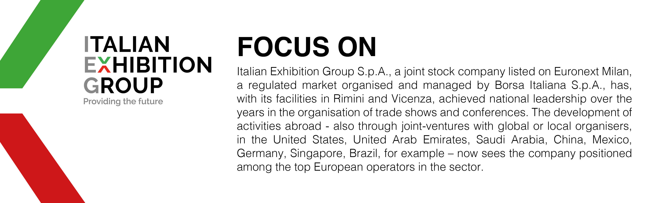

This press release contains forecast elements and estimates that reflect the management’s current opinions (“forward-looking statements”), particularly regarding future management performance, realization of investments, cash flow trends and the evolution of the financial structure. For their very nature, forward-looking statements have a component of risk and uncertainty, as they depend on the occurrence of future events. The effective results may differ (even significantly) from those announced, due to numerous factors, including, only by way of example: food service market and tourist flow trends in Italy, gold and jewellery market trends, green economy market trends; the evolution of raw material prices; general macroeconomic conditions; geopolitical factors and evolutions in the legislative framework. Moreover, the information contained in this release does not claim to be complete, and has not been verified by independent third parties. Forecasts, estimates and objectives contained herein are based on the information available to the Company as at the date of this release.

